Employee of the Month

Awarded to

Felix Anderson

For a stellar performance during the month of February
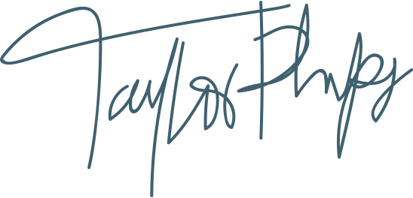
Taylor Phillips  Instructor |  | Date

